

**Faculty of engineering - Shoubra**

**Benha University**

**Research Article / Research Project / Literature Review**

in fulfillment of the requirements of

|  |  |
| --- | --- |
| **Department** | Engineering Mathematics and Physics |
| **Division** | ………………. |
| **Academic Year** | 2019-2020 Preparatory |
| **Course name** | Computer |
| **Course code** | ECE001 |
| **Github link** | <https://github.com/yasmin-mohamed/html.project.repository> |
| **Github page**  **(published-website)** | file:///D:/html.project/index.html.html |

**Title: -**

Build a website on recent computer engineering topics

Operating System

|  |  |  |  |
| --- | --- | --- | --- |
|  | Name | Edu mail | B.N |
| 1 | **ياسمين محمد احمد خليل الجد** | [yasmin196165@feng.bu.edu.eg](mailto:yasmin196165@feng.bu.edu.eg) | **1190** |

**Examiners committee**

|  |  |
| --- | --- |
| 1 | Dr.Ahmed Bayoumi |
| 2 | Dr.Shady Elmashad |
| 3 | Dr. Abdelhamid Attaby |

**Application Brief**

An operating system (OS) is the software component of a computer system that is responsible for the management and coordination of activities and the sharing of the resources of the computer. The OS acts as a host for application programs that are run on the machine. As a host, one of the purposes of an OS is to handle the details of the operation of the hardware. This relieves application programs from having to manage these details and makes it easier to write applications. Almost all computers use an OS of some type.

OSs offer a number of services to application programs and users. Applications access these services through application programming interfaces (APIs) or system calls. By using these interfaces, the application can request a service from the OS, pass parameters, and receive the results of the operation. Users may also interact with the OS by typing commands or using a graphical user interface (GUI).

**Types of Operating Systems:**

Following are some of the most widely used types of Operating system.

1. Simple Batch System
2. Multiprogramming Batch System
3. Multiprocessor System
4. Desktop System
5. Distributed Operating System
6. Clustered System
7. Real time Operating System
8. Handheld System

**Screenshots :**

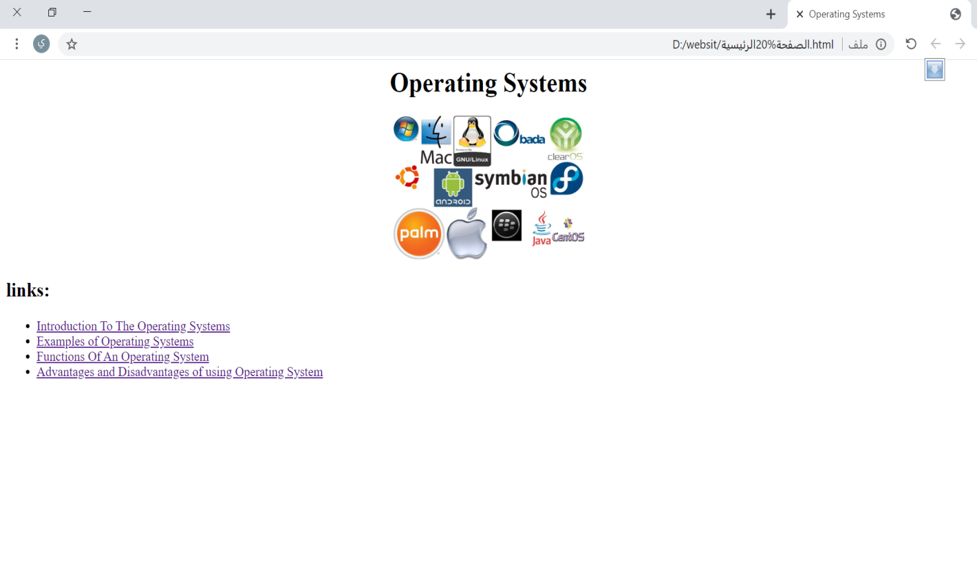

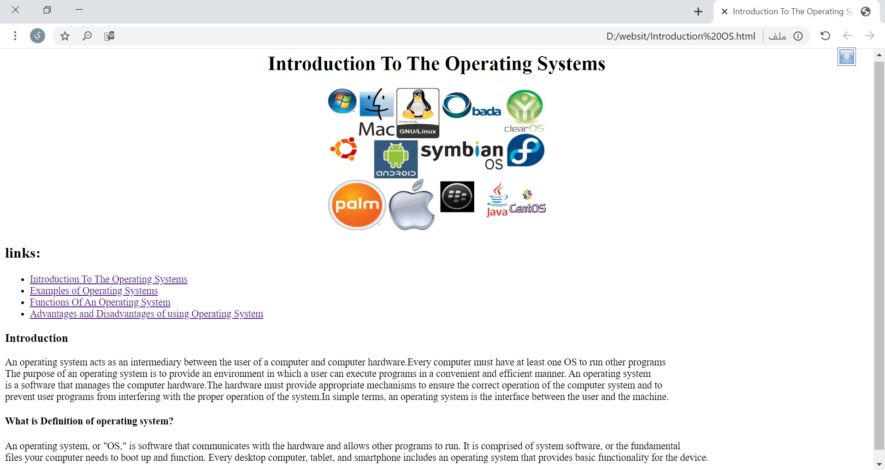

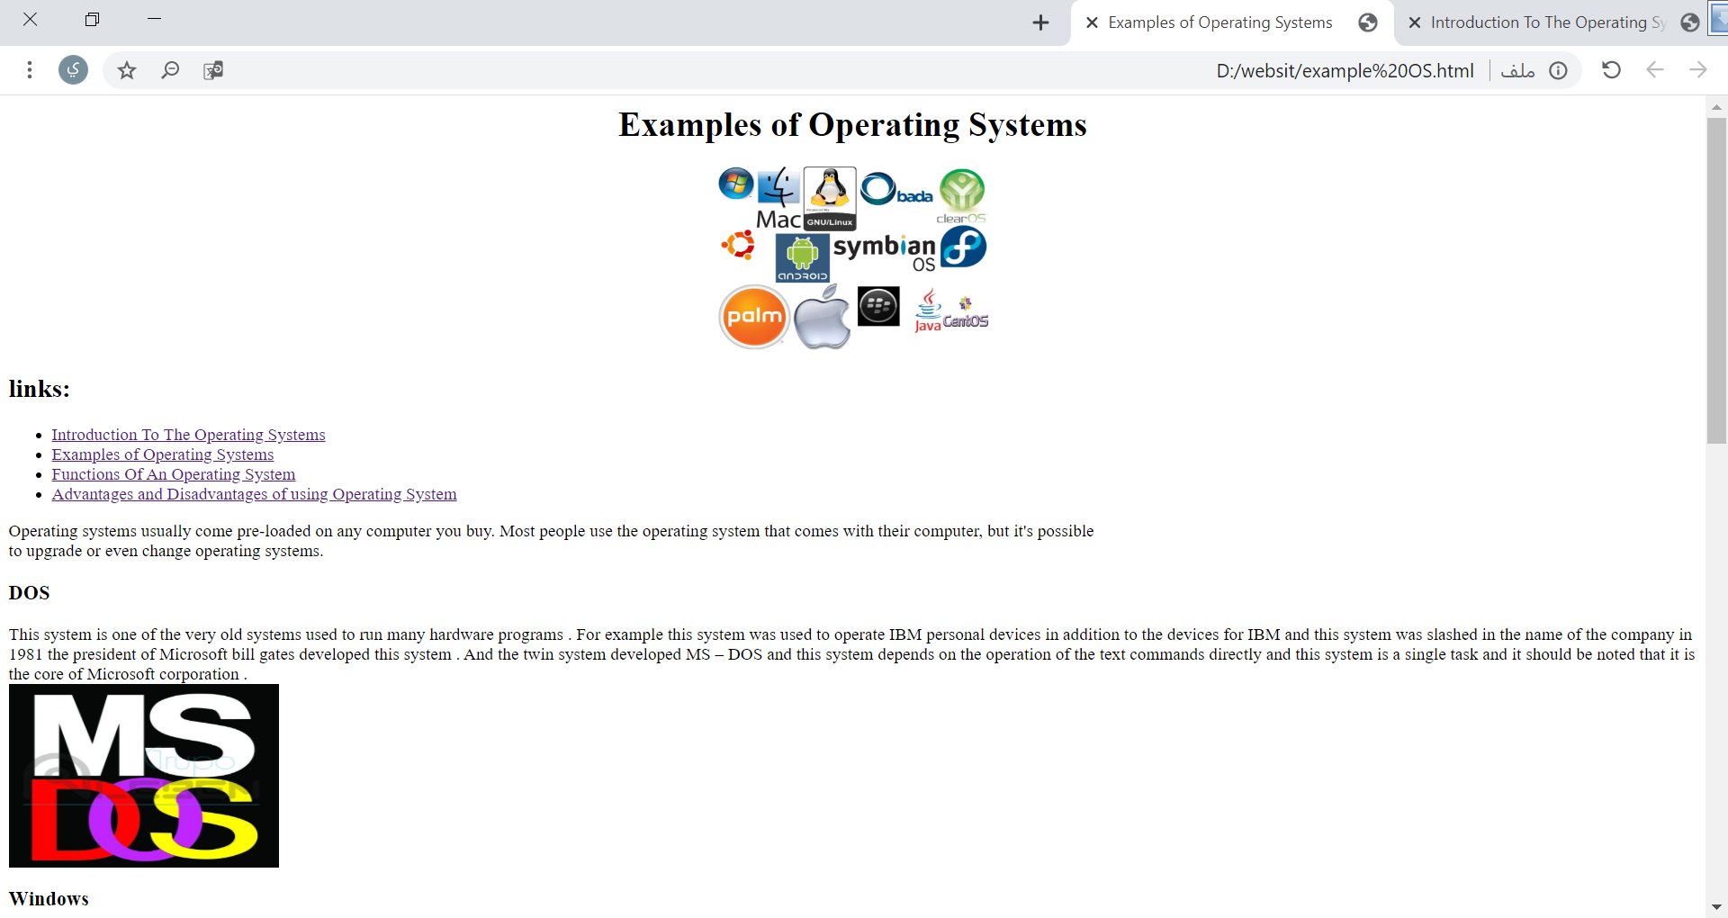

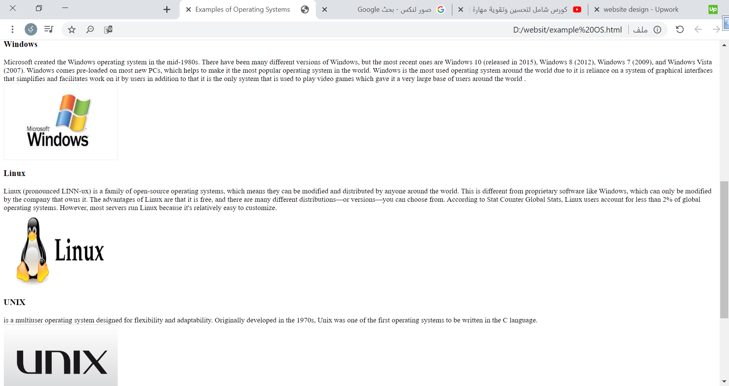

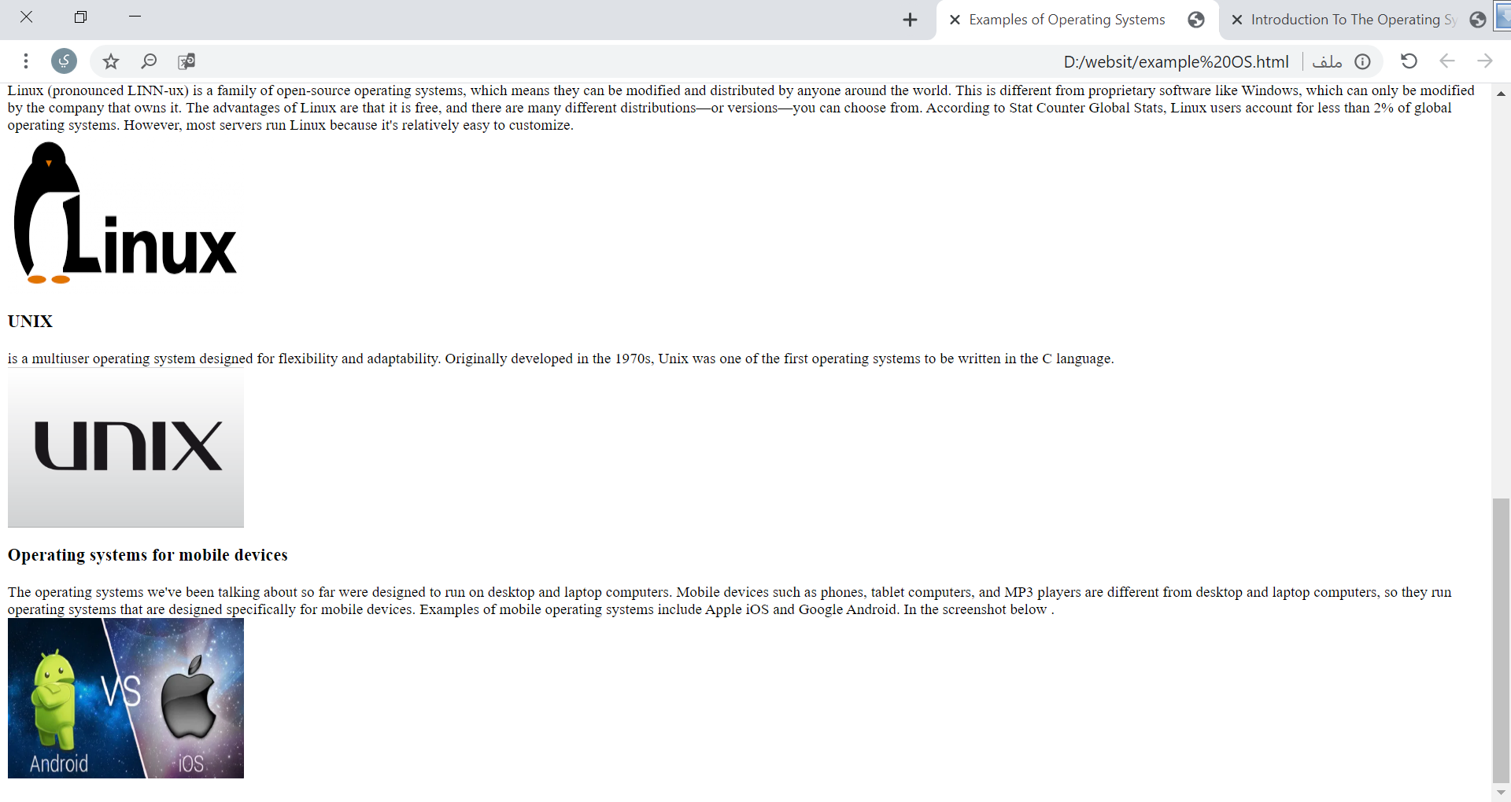

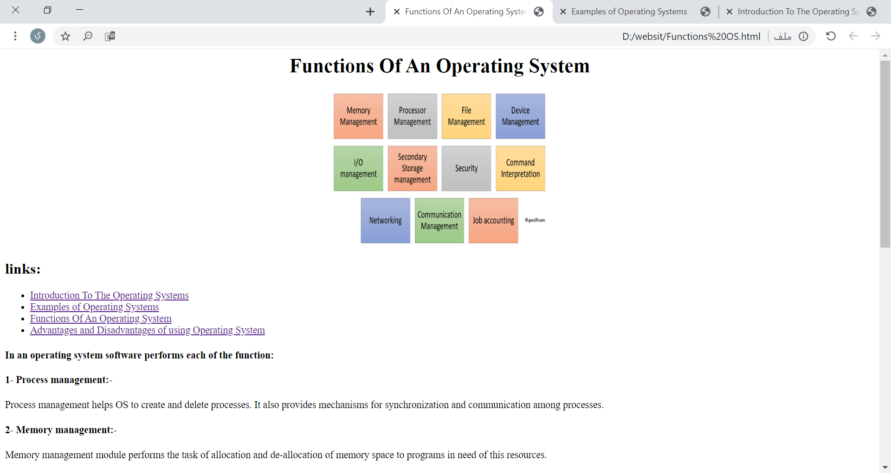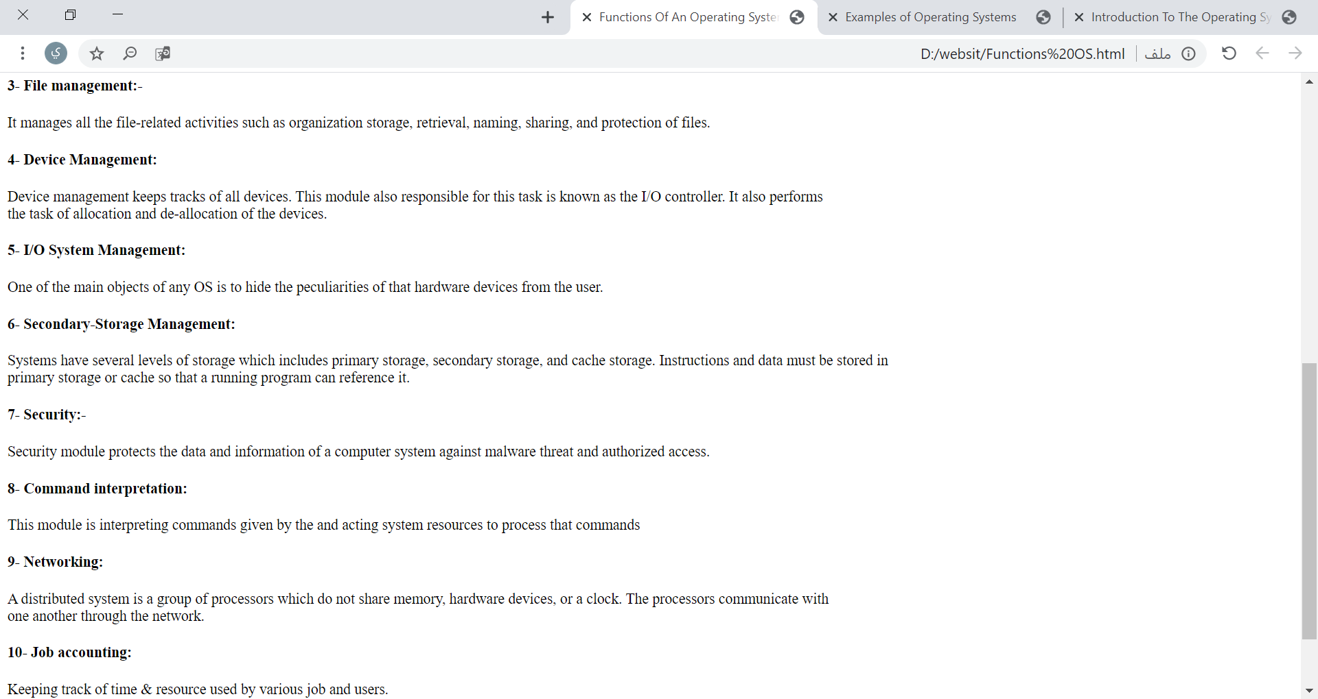

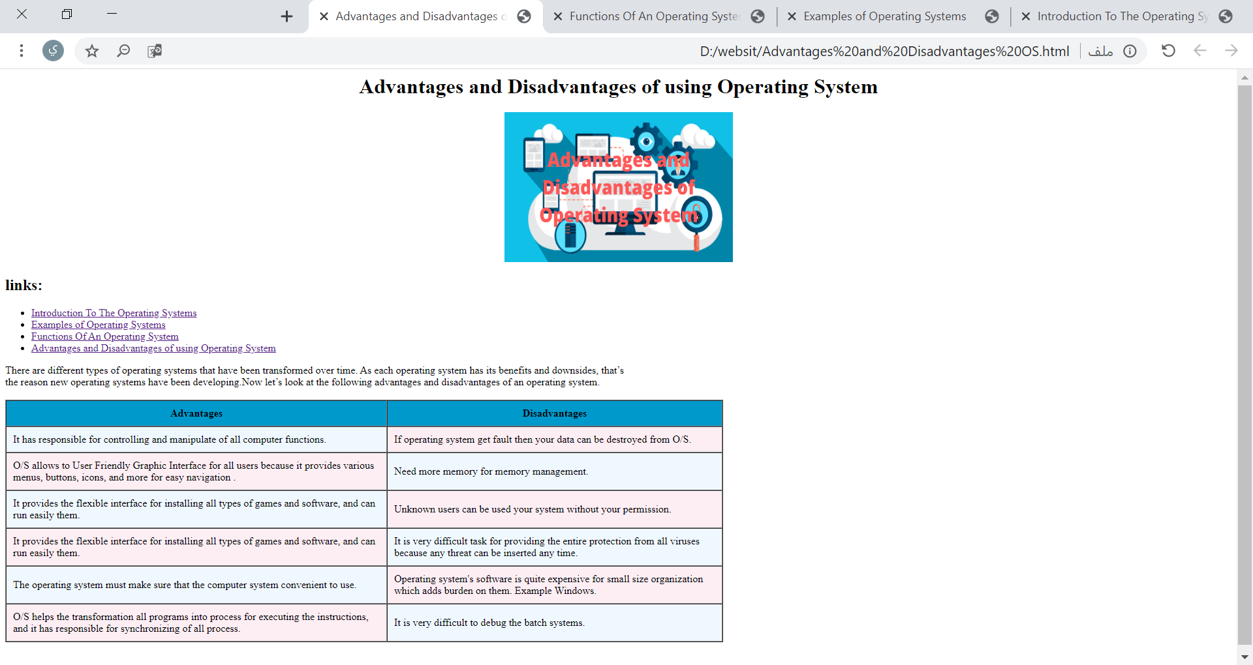

**Screenshot codes :**

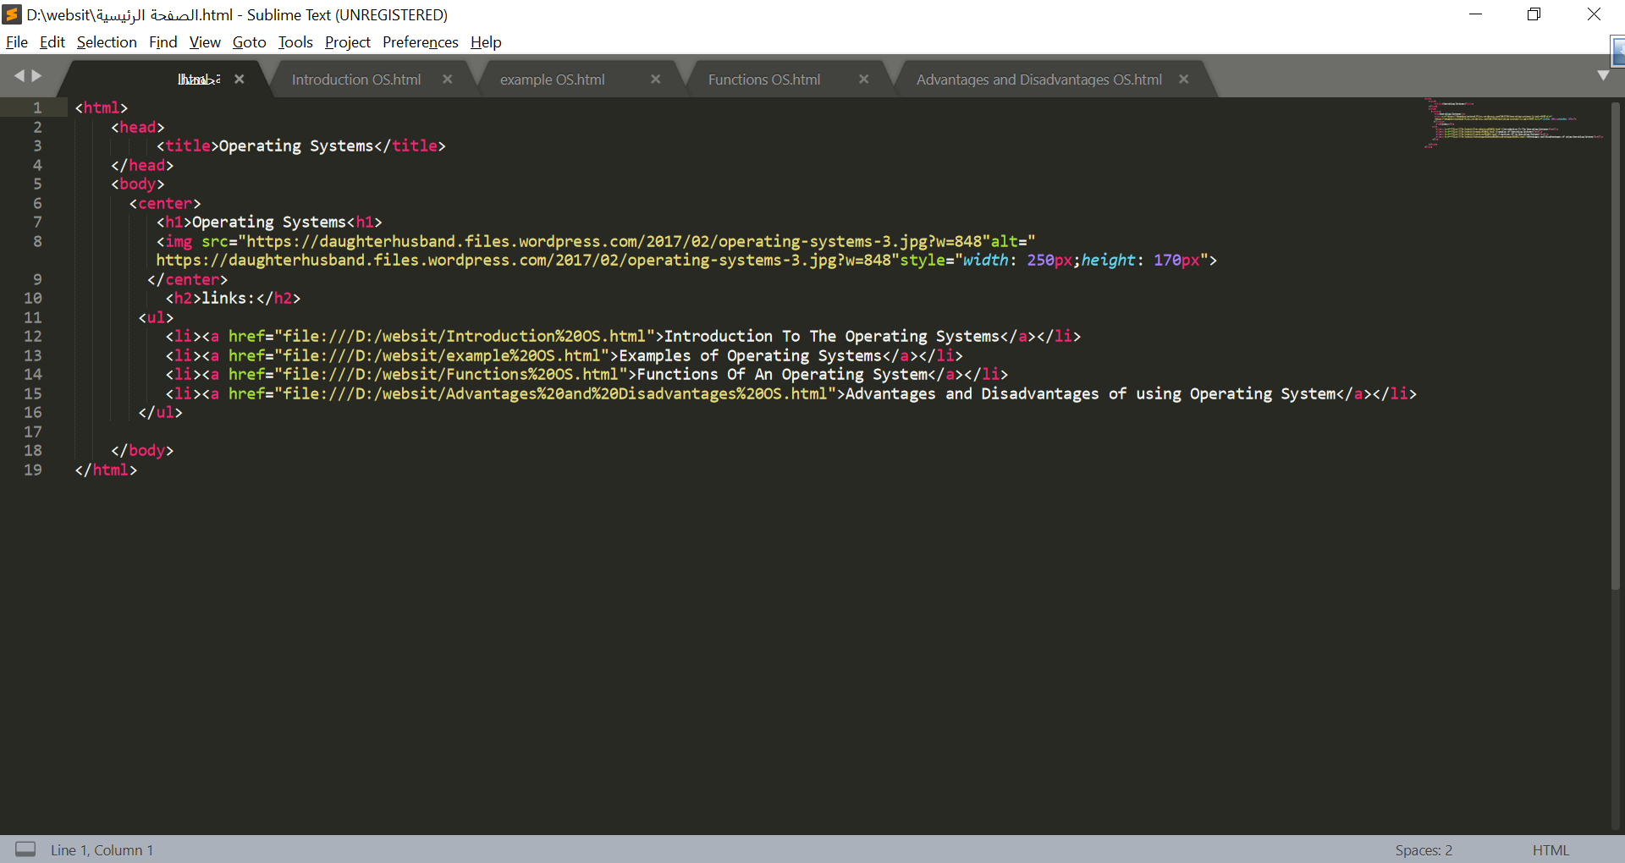

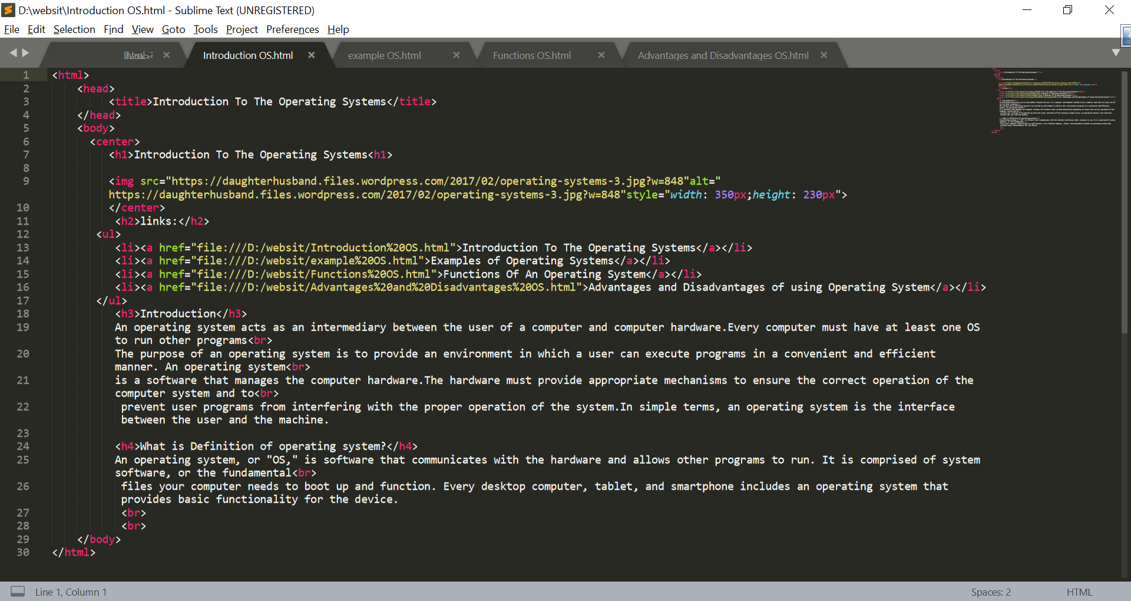

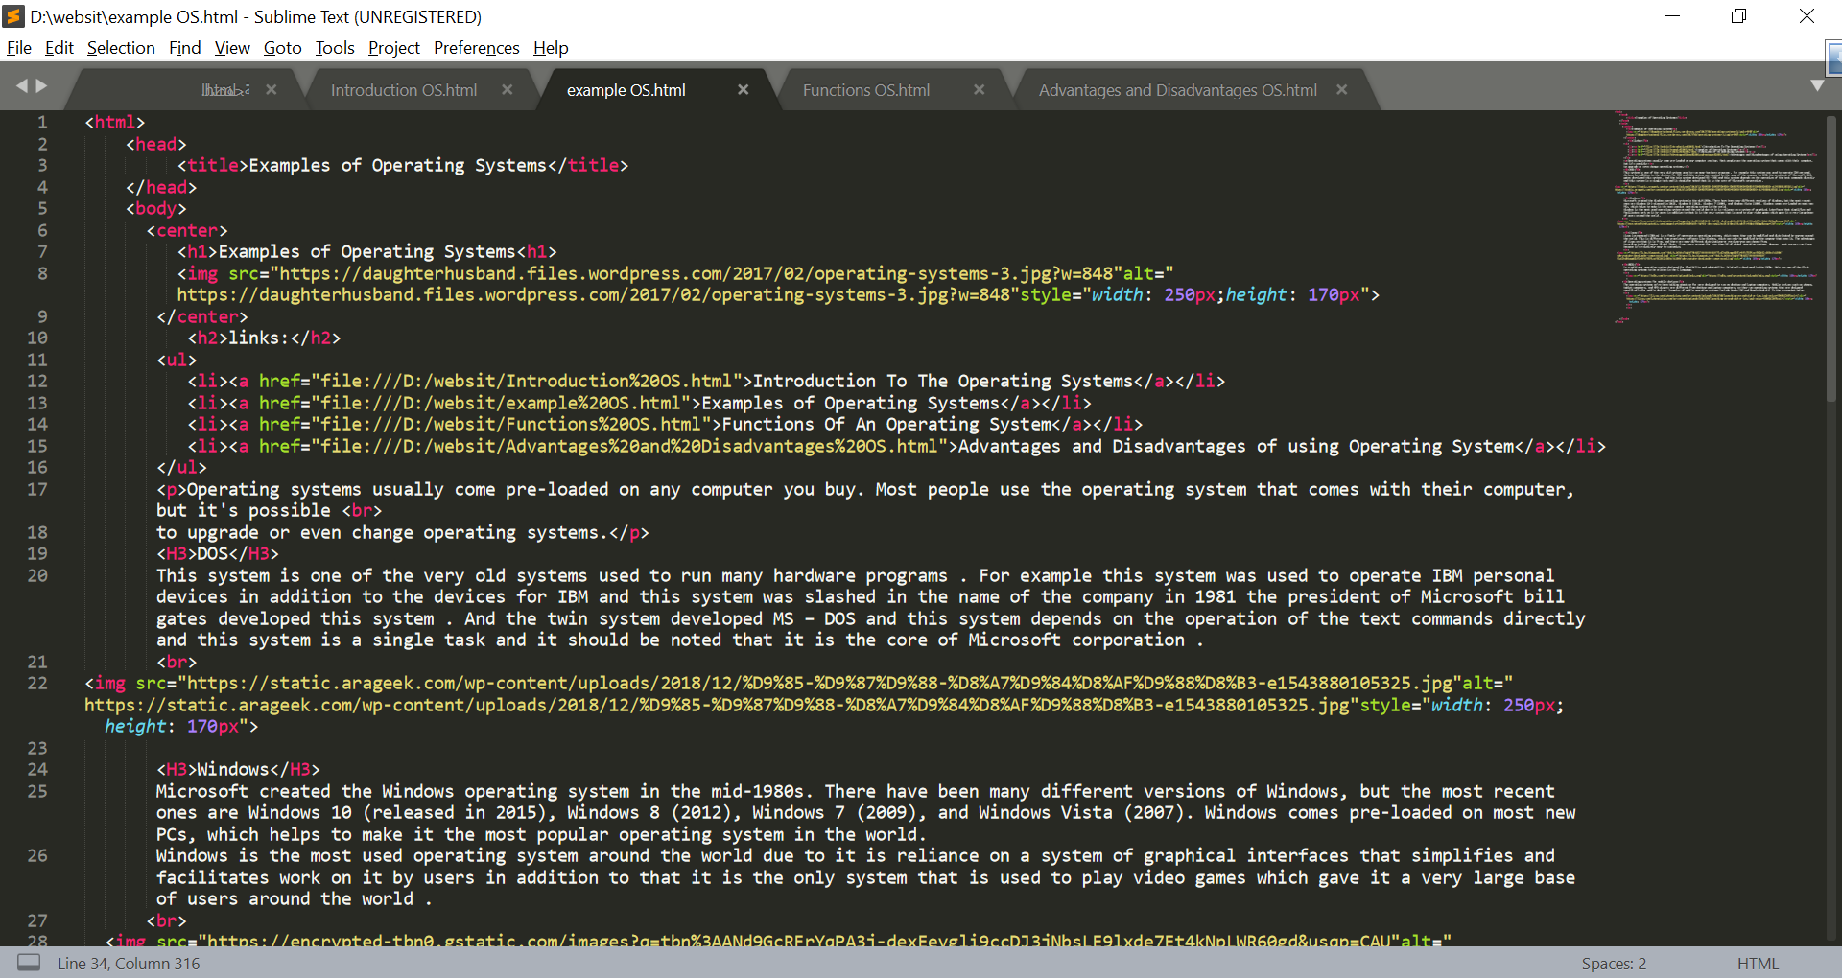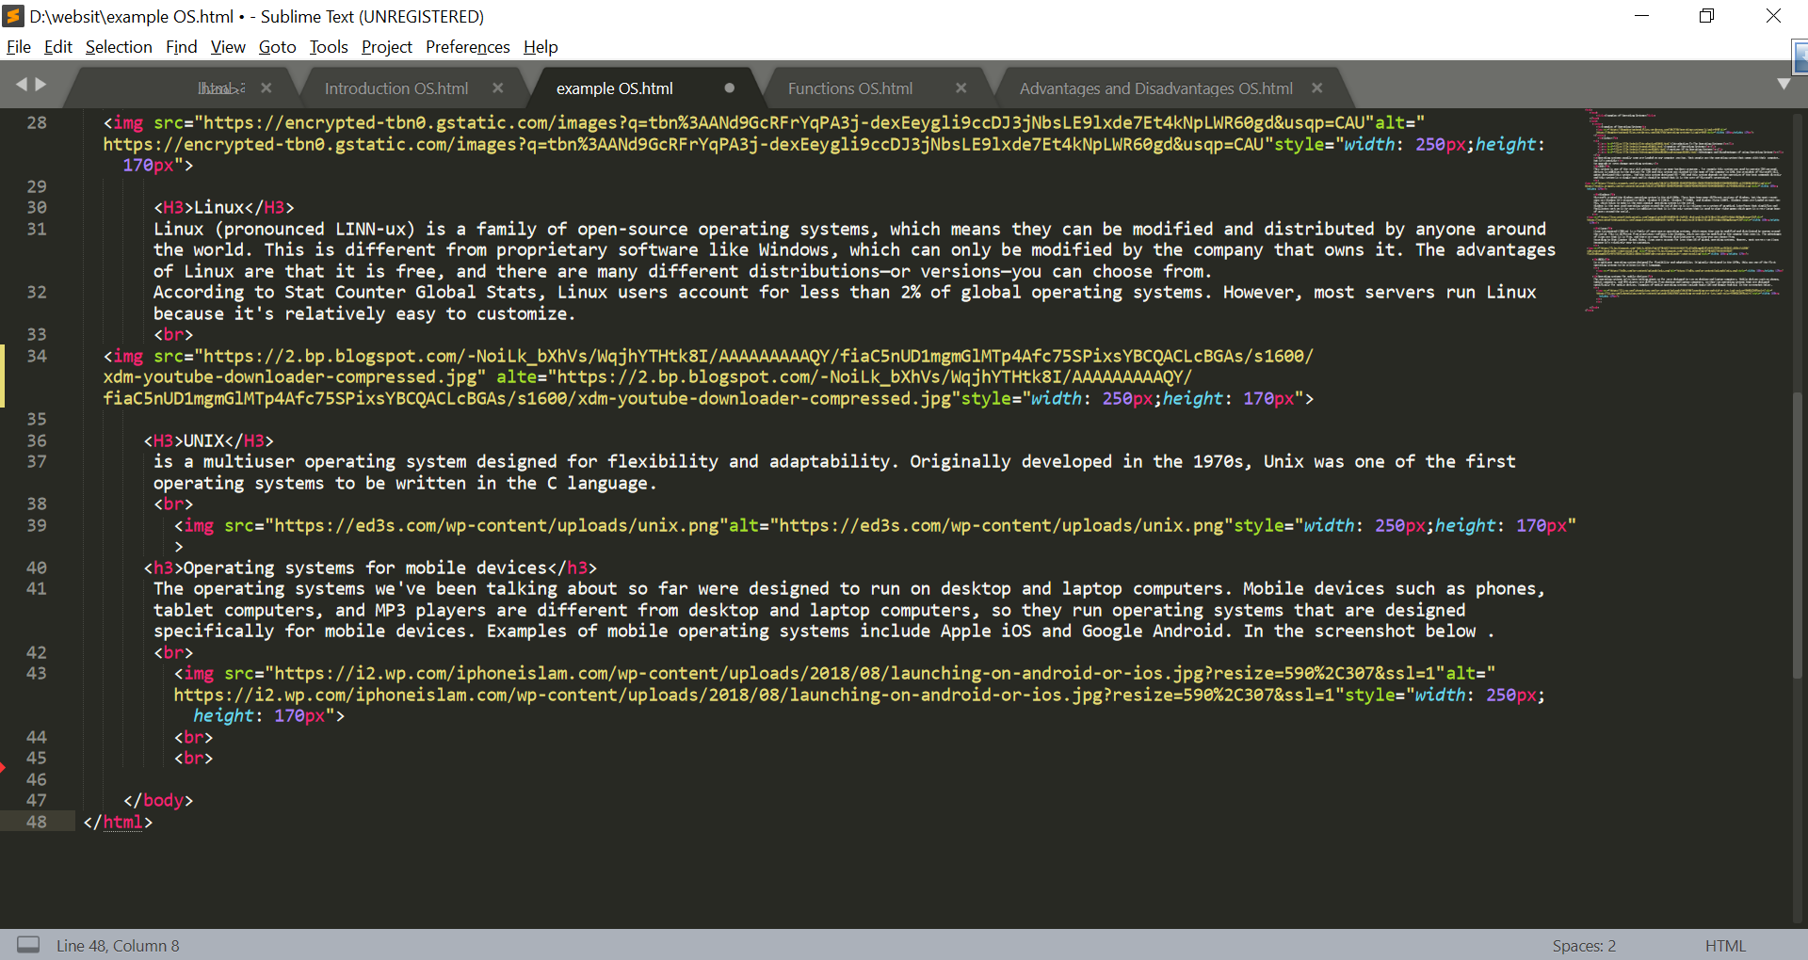

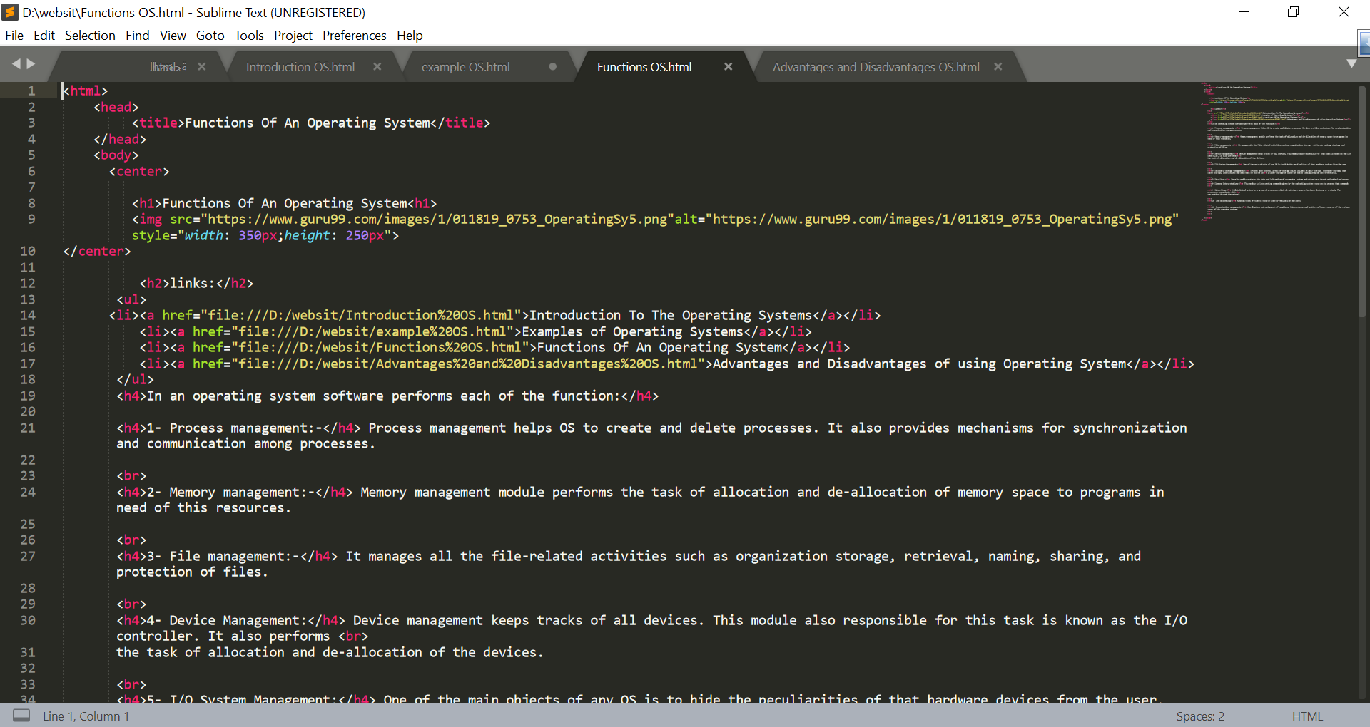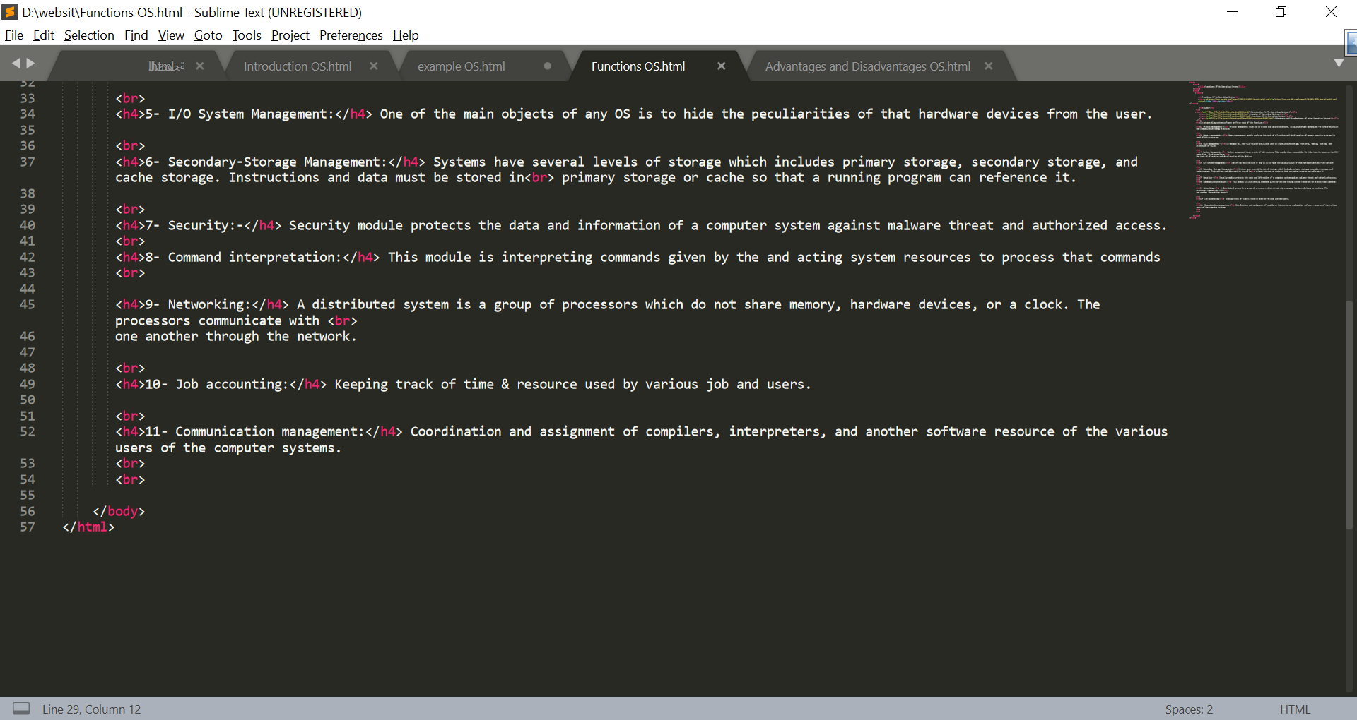

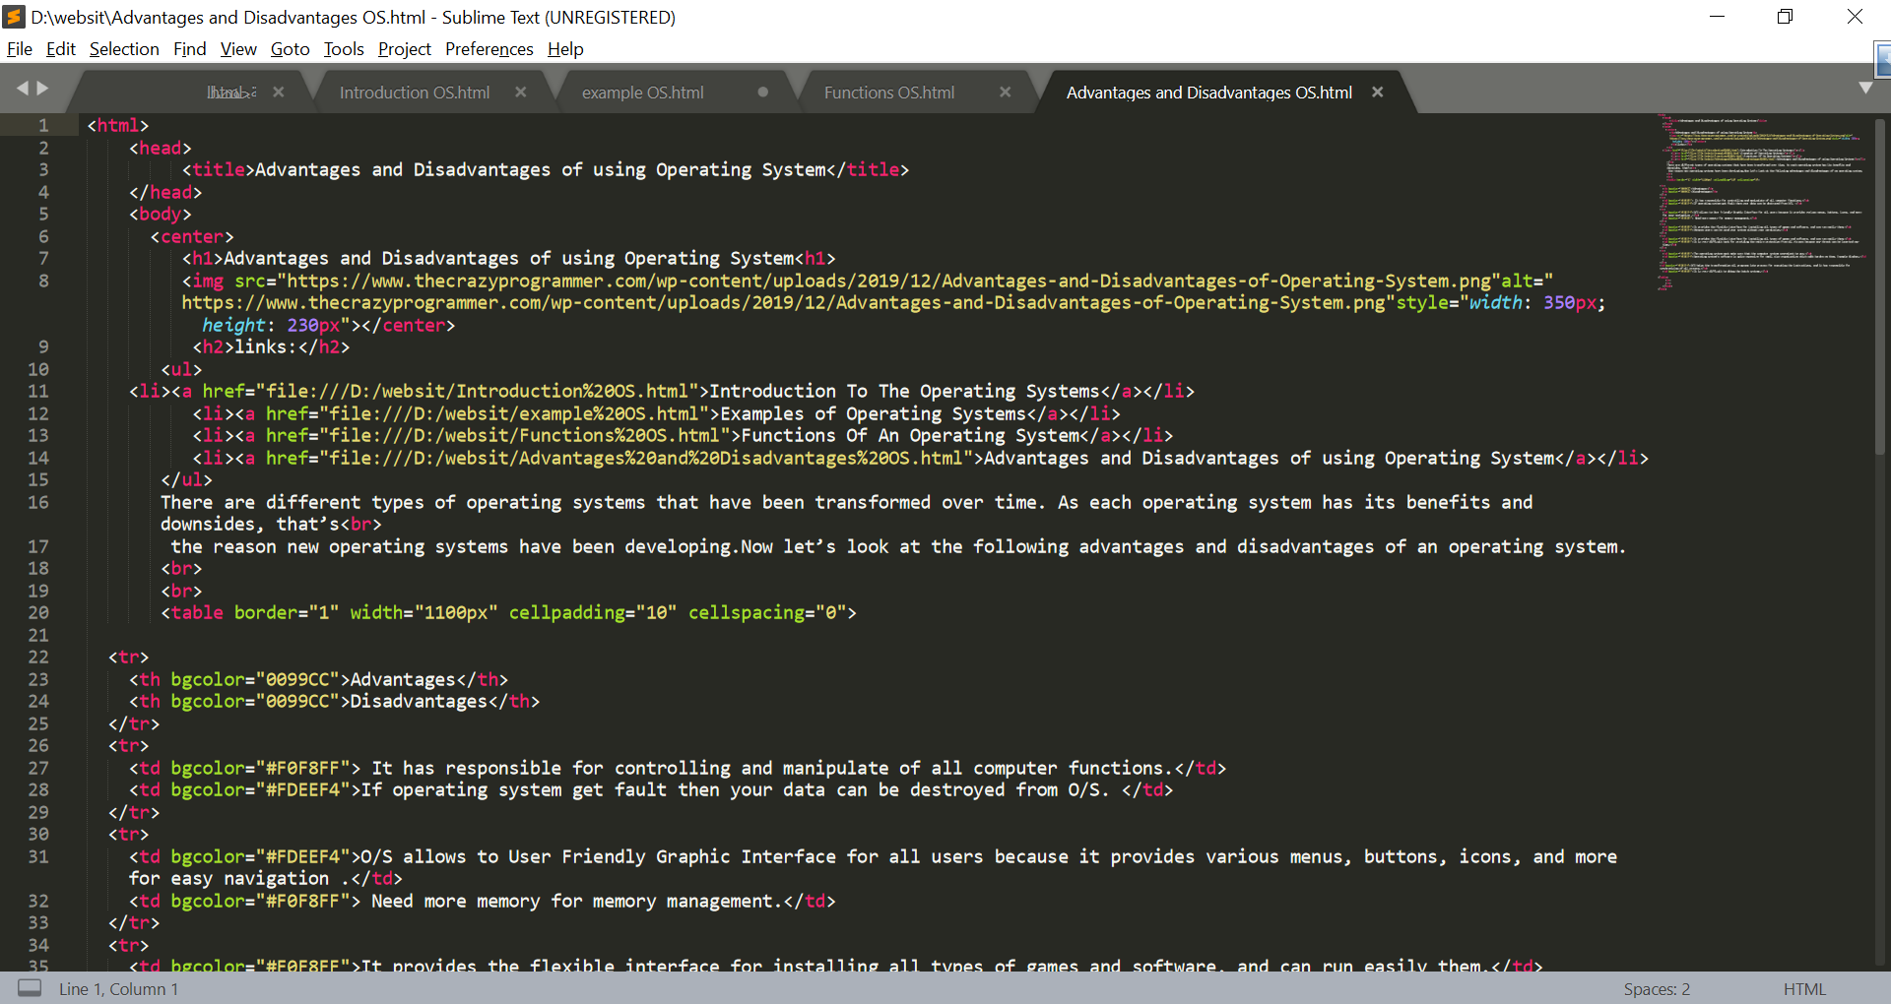

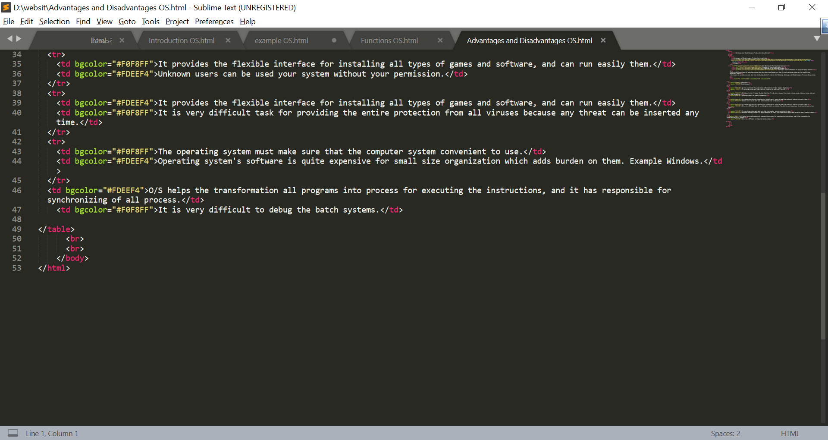

**References**

1-<http://digitalthinkerhelp.com/explain-importance-advantages-and-disadvantages-of-operating-system/>

2-<https://www.includehelp.com/operating-systems/advantages-and-disadvantages-of-different-types-of-operating-systems.aspx>

3-<https://edu.gcfglobal.org/en/computerbasics/understanding-operating-systems/1/>

4-<https://www.geeksforgeeks.org/introduction-of-operating-system-set-1/>

5-<http://openbookproject.net/courses/intro2ict/system/os_intro.html>

6-<https://edu.gcfglobal.org/en/computerbasics/understanding-operating-systems/1/>